**Instructions for Proctoring Make Up Final**

1. Print the pages that follow this page in this document.  
   (a) these are pages 2-8  
   (b) to duplicate the conditions for the other students taking the final, print the pages on BOTH sides of the sheet. This is not critical: you could also print on a single side of the sheet.
2. Hand the student the final examination and as many sheets of blank photocopy paper as he may need for the exam (which he may ask for during the exam)

Inform him that the blank sheets are in case his answers do not fit within the test pages, and that he should write the number and subpart (for example, “35 (b)”) on the blank pages to indicate how the answer belongs to the exam

1. The student is given 2 hours to complete the test, with nothing but a pencil or pen & eraser and the blank pages. No electronic devices (smartphone, tablet, laptop, etc) whatsoever.
2. When the student has completed the examination, please scan the pages of the examination using a scanner set at least 200 dpi (better 300 dpi) with grayscale or color mode each of the pages.  
   I do not recommend using a smartphone camera to take images of the pages, unless the lighting is excellent (uniform) and the image dimensions of the pages are 1700 x 2200 pixels for the width & length of a US letter page, respectively, without image distortion caused by perspective; often hard to achieve.
3. Email the scanned pages to [**smhbizness@gmail.com**](mailto:smhbizness@gmail.com).  
   Before doing anything to the examination as indicated below, please wait for my acknowledgement that I have received the exam image and retain the email acknowledgement until as such time that the course grade for the student is final and indisputable.

If you don’t wish to retain the examination paper for the required period of retaining examination papers, you can discard the examination or you can postal mail the exam to me S M Halloran, 5121 Andrea Blvd #67, Sacramento, CA 95842, if your policy requires it (I shouldn’t think it would).

**Physiology 115 Name ______________________________**Spring 2015

**MAKEUP FINAL**

For the multiple choice questions, there is *one* and *only one* best answer. READ THE OPTIONS CAREFULLY: multiple choice questions are formatted to reduce paper use and it can possibly be more troubling to comprehend options properly.

1. Which of these is made up of the protein actin?
   1. microtubules (b) microfilaments (c) intermediate filaments  
       (d) coated pits (e) none of the above
2. When splicing of pre-messenger RNA is done, this will be retained and become part of the messenger RNA (mRNA)?
   1. promoter (b) histone (c) poly(A) tail on 3’ end (d) exon (e) intron
3. Which of these is TRUE about a function of the outer membrane of mitochondria?
   1. it contains all the redox components in the electron transport system   
      (b) protons (H+) are move across it to build up a gradient to make   
      (c) enzymes like catalase and superoxide dismutase (SOD) are contained by it to reduce harmful oxygen species  
      (d) invaginations of this membrane increase the surface area to permit large amounts of ATP production  
      (e) it is a highly porous membrane that encloses the organelle
4. Very positively charged histone proteins use what type of chemical bond to help coil very negatively charged DNA?
   1. ionic bond (b) promoter bond (c) hydrogen bond (d) covalent bond (e) intron bond
5. A lysosome fused with a phagocytic vesicle. Which of these is FALSE?
   1. the lysosome contain proteins and other molecules that have digestive properties or chemical reactions that break down what is in the phagocytic vesicle
   2. the resulting vesicle has membrane protein transporters that are proton (H+) ATPases and will move H+ from the cytosol into the vesicle
   3. the pH within the vesicle will decrease
   4. both (a) and (b)
   5. none the above: all of the above are true
6. This kind of membrane protein is a classical example of one where a hormone (ligand) crosses through the membrane easily, binds to a receptor inside the cell, and the complex binds to DNA and starts gene transcription
   1. receptor tyrosine kinases (b) G protein-coupled receptors (c) steroid hormone receptors  
      (d) sodium (Na)/glucose transporter (e) ribosome-activation factor
7. This cell junction type controls paracellular transport: that is, it seals layers of cells against substances and things moving *between* cells rather than through them?
   1. adherens junction (b) desmosome (c) gap junction (d) nuclear pore (e) tight junction
8. The onset of the condensed chromosomes visibly moving apart from each other from the spindle equator is what phase of mitosis?
   1. prophase (b) prometaphase (c) metaphase (d) anaphase (e) telophase
9. What is a term for the process when tRNA with an amino acids enters the A site of the ribosome, with its anticodon matched to the mRNA codon?
   1. transcription (b) replication (c) decoding (d) translocation (e) transpeptidation
10. These are required to bring the RNA polymerase to the DNA where transcription starts:
    1. transcription factors bind to promoter (b) histones forming nucleosomes  
       (c) nuclear pores allowing exit of mRNA (d) exons being spliced out
11. Which of these describes oxidative phosphorylation?
    1. ATP is produced by proton (H+) gradients across mitochondrial inner membrane in electron transport
    2. ATP is produced from a reaction in glycolysis or the TCA cycle
    3. GTP is used to move ribosome during translation the distance of one codon or 3 nucleotides
    4. ATP is used to move vesicles along a microtubule
    5. ATP is produced during ribosome assembly in the nucleus
12. A genome has 35% G. Which of the following is FALSE about the genome?
    1. it has 35% C (b) it has 15% A (c) the sum of the pyrimidine content is 50% (d) %T + %A = 50%
13. This structure for coiling DNA about twice around a core set of histones is called
    1. solenoid (b) chromatid (c) chromosome (d) centriole (e) nucleosome
14. At the molecular level, this represents the many variations in the DNA sequences of a gene that show up as a variation in the trait corresponding to that gene
    1. intron (b) exon (c) genome (d) allele (e) locus
15. Oligonucleotide A has a higher melting temperature (Tm) than oligonucleotide B, and both have the same length (same number of base pairs). Which of these is clearly understood to be FALSE?
    1. %AT content of oligo A is lower than oligo B   
       (b) %GC content of oligo B is lower than that of oligo A  
        (c) the absorbance at 260 nm of oligo A will increase as temperature goes up  
       (d) the melting of oligo B is denaturation: forming two single-strands of DNA from double-stranded DNA
16. Which of these is NOT a feature of the Golgi apparatus?
    1. it has a *trans* face that receives vesicles from the endoplasmic reticulum (ER)
    2. everything starts with vesicle fusion to the *cis* face of the Golgi
    3. it has cisternae like the endoplasmic reticulum also has cisternae
    4. lysosomes arise from vesicles formed in the Golgi
    5. glycoproteins get modified within the Golgi
17. Which of these is a feature found in RNA?

(a) 2’-deoxyribose (A) (b) thymine (T) (c) protein (d) ribose (e) lipid

1. The TCA cycle occurs where?

(a) mitochondrial inner membrane (b) mitochondrial intermembrane space   
(c) mitochondrial matrix (d) cytosol (e) peroxisome

1. In the smooth endoplasmic reticulum (SER) these are enzymes that metabolize toxic substances:
2. cytochrome P450 enzymes (b) ribosomes (c) RNA polymerases (d) cisternae (e) lamins
3. A steroid hormone passes directly through the phospholipid bilayer membrane from a high concentration to a low concentration without needing transport protein. What is this an example of?
4. simple passive diffusion (b) exocytosis (c) receptor-mediated endocytosis  
   (d) facilitated diffusion (e) coupled active transport
5. A vesicle comes off the *trans* face of the Golgi and makes its way to the plasma membrane fusing with it immediate and expelling its contents exocytically. Which of the terms below describes this process?  
   (a) phagocytosis (b) simple passive diffusion (c) regulated secretion  
   (d) constitutive secretion (e) lysosomal formation
6. This enzyme makes RNA required to start DNA replication:

(a) RNA primase (b) ribosomal RNA (c) RNA ligase (d) RNA polymerase II (e) Na/K ATPase

1. Which of these RNA molecule types provides the actual code of amino acids for making a polypeptide during protein synthesis?
2. messenger RNA (mRNA) (b) ribosomal RNA (rRNA) (c) promoter RNA (pRNA)  
   (d) transfer RNA (tRNA) (e) carrier RNA (cRNA)
3. How many possible codons are there in the “genetic code” (remember: there are 4 bases and 3 possible base positions making up a codon…do the math)?
4. 0 (b) 2 (c) 3 (d) 20 (e) 64
5. Which of these is TRUE with respect to the termination of eukaryotic translation?
6. it requires proteins called transcription factors to bind to the promoter
7. a poly(A) tail will be added to the 3’ end of the messenger RNA
8. the ribosome A site must be positioned on a stop codon
9. exons will be spliced out of the RNA to make the final message
10. Which of these is FALSE with respect to the initiation of transcription?
11. DNA polymerase be used
12. RNA will be synthesized in the 5’🡪3’ direction
13. it requires transcription factors
14. it requires promoters
15. These are polymers of keratin that connect to desmosomes within cells subjected to mechanical stress
    1. intermediate filaments (b) adherens junction (c) microfilaments  
       (d) microtubules (e) peroxisomes
16. Pyruvate is metabolized by the pyruvate dehydrogenase enzyme to form a 2-carbon product. Which of these is a TRUE statement about that reaction?
    1. CO2 is a reactant (consumed in the reaction) (b) the 2-carbon product is acetyl-CoA   
       (c) NADH is formed (d) the 2-carbon product is ethanol (e) glucose is a reactant
17. NADH is *formed* in which of these metabolic processes?
    1. glycolysis (b) TCA cycle (c) electron transport (d) DNA replication (e) both (a) & (b)
18. A single FADH2 molecule will produce how many ATP in the electron transport system?
    1. 1 (b) 2 (c) 3 (d) 32 (e) 38
19. What is the term for the physical location on the chromosome where a gene is found?
    1. allele (b) centromere (c) locus (d) genome (e) Golgi
20. Osmosis is the diffusion of what molecule or type of molecule?
    1. carbon dioxide (CO2) (b) water (H2O) (c) amino acids (d) lipids (e) carbohydrates

33. (a) Draw a very simple diagram showing the relationship of the mitochondrial inner membrane, intermembrane space, outer membrane and matrix. (b) Show which side NADH is on when it interacts with the electron transport system in the membrane. (c) Show how protons move across one of the parts of the mitochondria above and where the high concentration side of H+ is. (d) Show how ATP is formed.

1. How many ATP are formed from one NADH  
     
   (f) How many H+ are required to form one ATP molecule?

(g) Oxidative phosphorylation produces ATP from a concentration difference of ions moving across a membrane from high concentration to low concentration coupled to a membrane protein. Name any membrane protein learned that does the opposite and utilizes ATP to move ions from low concentration to high concentration (against their gradient)?

34. (a) Nucleotides have 3 parts to their structure: name them *or* draw their structure  
  
  
(b) The 5 nitrogenous bases that make up are members of TWO classes of structures that begin with the letter “P.” (i) What is the name of the one class that has a chemical structure with two rings fused to each other, one pentagonal and the other hexagonal? (ii) Also write the one-letter symbol or the name of one nitrogenous base that is a member of it.  
  
  
(c) (i) What is the name of the other class with a single hexagonal ring as its chemical structure?  
(ii) Also write the one-letter symbol or the name of one nitrogenous base that is a member of it

35. The double-stranded DNA helix has different conformations.  
(a) What is the classic Watson-Crick conformation with the right-handed helical twist called?  
(b) what is the form of DNA called that has a zig-zag left-handed twist and is transcriptionally inactive?

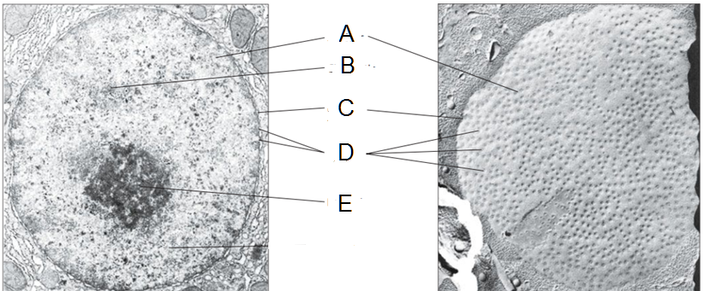

36. The figure above are two electron micrographs of a nucleus with fundamental parts labeled, and used in lecture. From the description below and using the labeled images above, write the NAME of the part of the nucleus. Item A is already labeled for you

A] ________________________ the organelle of the cell that contains its genome and is enclosed in  
two membranes and protects that genome from being altered by biochemical reactions occurring elsewhere in the cell

Nucleus

B] _______________________ this is the term given to the combination of DNA, RNA, and proteins that help to coil and manage the DNA making up genome  
(single 9-letter word)

C] _______________________ refers to the structure made of two membranes, inner and outer, with a perinuclear space in between (two words, total 15 letters)

D] _______________________ this is the term for a structure that has an annulus made up of an octameric protein through which all molecules like mRNA pass through to get in or out of nucleus (two words, total 12 letters, plural)

E] _______________________ this is a structural feature seen under the microscope where ribosomes are assembled from the proteins and ribosome RNA present in large amounts here, accounting for its special microscopic distinction from the nucleoplasm  
(9 letter word)

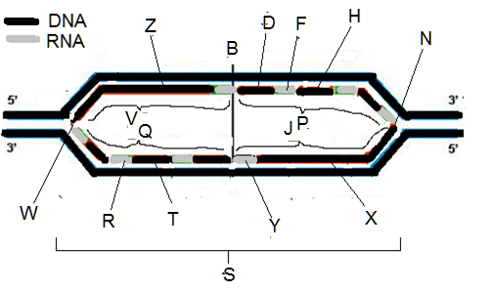37. Above is a figure relevant to the replication of DNA showing DNA and RNA strands. There may be several possibilities for answers below in the diagram above. You only need enter one answer.

(a) ___ replication origin (b) ___ newly made DNA  
(c) ___ lagging strand (d)___ replication fork  
(e) ___ RNA primer (f) ___ replication bubble  
(g) ___ leading strand

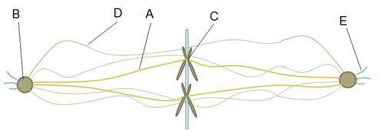

38. The figure above is taken from the presentation on mitosis and specifically talks about the types of microtubules involved in mitosis

A] _______________________ this is the name of the microtubule in mitosis that connects spindle pole to chromosome

B] _______________________ this term is used for spindle pole that radiates out microtubules during mitosis

C] _______________________ this term is for structure that connects the centromere of the chromosome to the type of microtubule labeled A

D] ________________________ this is the name of the microtubule in mitosis that connects one spindle pole with the other that pushes the poles apart

E] _______________________ this is the name of the microtubule in mitosis that connects spindle pole to the plasma membrane so that the poles can be further pulled apart from each other during mitosis

F] These are two structures at right angles to each other and have a pinwheel array of 9 fused triplet formations of microtubules.

G] This structure is actually composed of the two structures described in item F, and forms a microtubule-organizing center located near the nucleus and is vital for mitosis, wherein it duplicates and then migrates to form the spindle poles in mitosis?

H] All microtubules are made up of these two proteins: what are the names of these proteins?